IEEE TRANSACTIONS ON KNOWLEDGE AND DATA ENGINEERING, VOL. 25, NO. 1, JANUARY 2013 | 1

- Fast Clustering-Based Feature Subset Selection Algorithm for

High-Dimensional Data

Qinbao Song, Jingjie Ni, and Guangtao Wang

Abstract—Feature selection involves identifying a subset of the most useful features that produces compatible results as the original entire set of features. A feature selection algorithm may be evaluated from both the efficiency and effectiveness points of view. While the efficiency concerns the time required to find a subset of features, the effectiveness is related to the quality of the subset of features. Based on these criteria, a fast clustering-based feature selection algorithm (FAST) is proposed and experimentally evaluated in this paper. The FAST algorithm works in two steps. In the first step, features are divided into clusters by using graph-theoretic clustering methods. In the second step, the most representative feature that is strongly related to target classes is selected from each cluster to form a subset of features. Features in different clusters are relatively independent, the clustering-based strategy of FAST has a high probability of producing a subset of useful and independent features. To ensure the efficiency of FAST, we adopt the efficient minimum-spanning tree (MST) clustering method. The efficiency and effectiveness of the FAST algorithm are evaluated through an empirical study. Extensive experiments are carried out to compare FAST and several representative feature selection algorithms, namely, FCBF, ReliefF, CFS, Consist, and FOCUS-SF, with respect to four types of well-known classifiers, namely, the probability-based Naive Bayes, the tree-based C4.5, the instance-based IB1, and the rule-based RIPPER before and after feature selection. The results, on 35 publicly available real-world high-dimensional image, microarray, and text data, demonstrate that the FAST not only produces smaller subsets of features but also improves the performances of the four types of classifiers.

Index Terms—Feature subset selection, filter method, feature clustering, graph-based clustering

Ç

- INTRODUCTION

_{W}ITH the aim of choosing a subset of good features with respect to the target concepts, feature subset selection is an effective way for reducing dimensionality, removing

irrelevant data, increasing learning accuracy, and improv-ing result comprehensibility [43], [46]. Many feature subset selection methods have been proposed and studied for machine learning applications. They can be divided into four broad categories: the Embedded, Wrapper, Filter, and Hybrid approaches.

The embedded methods incorporate feature selection as a part of the training process and are usually specific to given learning algorithms, and therefore may be more efficient than the other three categories [28]. Traditional machine learning algorithms like decision trees or artificial neural networks are examples of embedded approaches

- The wrapper methods use the predictive accuracy of a predetermined learning algorithm to determine the good-ness of the selected subsets, the accuracy of the learning algorithms is usually high. However, the generality of the selected features is limited and the computational complex-ity is large. The filter methods are independent of learning

. The authors are with the Department of Computer Science and Technology, Xi’an Jiaotong University, 28 Xian-Ning West Road, Xi’an, Shaanxi 710049, P.R. China.

E-mail: qbsong@mail.xjtu.edu.cn, {ni.jingjie, gt.wang}@stu.xjtu.edu.cn.

Manuscript received 1 Feb. 2011; revised 18 July 2011; accepted 26 July 2011;
published online 5 Aug. 2011.
Recommended for acceptance by C. Shahabi.

For information on obtaining reprints of this article, please send e-mail to: tkde@computer.org, and reference IEEECS Log Number TKDE-2011-02-0047. Digital Object Identifier no. 10.1109/TKDE.2011.181.

algorithms, with good generality. Their computational complexity is low, but the accuracy of the learning algorithms is not guaranteed [13], [63], [39]. The hybrid methods are a combination of filter and wrapper methods [49], [15], [66], [63], [67] by using a filter method to reduce search space that will be considered by the subsequent wrapper. They mainly focus on combining filter and wrapper methods to achieve the best possible performance with a particular learning algorithm with similar time complexity of the filter methods. The wrapper methods are computationally expensive and tend to overfit on small training sets [13], [15]. The filter methods, in addition to their generality, are usually a good choice when the number of features is very large. Thus, we will focus on the filter method in this paper.

With respect to the filter feature selection methods, the application of cluster analysis has been demonstrated to be more effective than traditional feature selection algorithms. Pereira et al. [52], Baker and McCallum [4], and Dhillon et al. [18] employed the distributional clustering of words to reduce the dimensionality of text data.

In cluster analysis, graph-theoretic methods have been well studied and used in many applications. Their results have, sometimes, the best agreement with human perfor-mance [32]. The general graph-theoretic clustering is simple: compute a neighborhood graph of instances, then delete any edge in the graph that is much longer/shorter (according to some criterion) than its neighbors. The result is a forest and each tree in the forest represents a cluster. In our study, we apply graph-theoretic clustering methods to features. In particular, we adopt the minimum spanning

1041-4347/13/$31.00 2013 IEEE Published by the IEEE Computer Society

2 IEEE TRANSACTIONS ON KNOWLEDGE AND DATA ENGINEERING, VOL. 25, NO. 1, JANUARY 2013

tree (MST)-based clustering algorithms, because they do not assume that data points are grouped around centers or separated by a regular geometric curve and have been widely used in practice.

Based on the MST method, we propose a Fast clustering-bAsed feature Selection algoriThm (FAST). The FAST algorithm works in two steps. In the first step, features are divided into clusters by using graph-theoretic clustering methods. In the second step, the most representative feature that is strongly related to target classes is selected from each cluster to form the final subset of features. Features in different clusters are relatively independent, the clustering-based strategy of FAST has a high probability of producing a subset of useful and independent features. The proposed feature subset selection algorithm FAST was tested upon 35 publicly available image, microarray, and text data sets. The experimental results show that, compared with other five different types of feature subset selection algorithms, the proposed algorithm not only reduces the number of features, but also improves the performances of the four well-known different types of classifiers.

The rest of the paper is organized as follows: in Section 2, we describe the related works. In Section 3, we present the new feature subset selection algorithm FAST. In Section 4, we report extensive experimental results to support the proposed FAST algorithm. Finally, in Section 5, we summarize the present study and draw some conclusions.

- RELATED WORK

Feature subset selection can be viewed as the process of identifying and removing as many irrelevant and redun-dant features as possible. This is because 1) irrelevant features do not contribute to the predictive accuracy [33], and 2) redundant features do not redound to getting a better predictor for that they provide mostly information which is already present in other feature(s).

Of the many feature subset selection algorithms, some can effectively eliminate irrelevant features but fail to handle redundant features [23], [31], [37], [34], [45], [59], yet some of others can eliminate the irrelevant while taking care of the redundant features [5], [29], [42], [68]. Our proposed FAST algorithm falls into the second group.

Traditionally, feature subset selection research has focused on searching for relevant features. A well-known example is Relief [34], which weighs each feature according to its ability to discriminate instances under different targets based on distance-based criteria function. However, Relief is ineffective at removing redundant features as two predictive but highly correlated features are likely both to be highly weighted [36]. Relief-F [37] extends Relief, enabling this method to work with noisy and incomplete data sets and to deal with multiclass problems, but still cannot identify redundant features.

However, along with irrelevant features, redundant features also affect the speed and accuracy of learning algorithms, and thus should be eliminated as well [36], [35],

- CFS [29], FCBF [68], and CMIM [22] are examples that take into consideration the redundant features. CFS [29] is achieved by the hypothesis that a good feature subset is one that contains features highly correlated with the target, yet

uncorrelated with each other. FCBF ([68], [71]) is a fast filter method which can identify relevant features as well as redundancy among relevant features without pairwise correlation analysis. CMIM [22] iteratively picks features which maximize their mutual information with the class to predict, conditionally to the response of any feature already picked. Different from these algorithms, our proposed the FAST algorithm employs the clustering-based method to choose features.

Recently, hierarchical clustering has been adopted in word selection in the context of text classification (e.g., [52], [4], and [18]). Distributional clustering has been used to cluster words into groups based either on their participation in particular grammatical relations with other words by Pereira et al. [52] or on the distribution of class labels associated with each word by Baker and McCallum [4]. As distributional clustering of words are agglomerative in nature, and result in suboptimal word clusters and high computational cost, Dhillon et al. [18] proposed a new information-theoretic divisive algorithm for word cluster-ing and applied it to text classification. Butterworth et al. [8] proposed to cluster features using a special metric of Barthelemy-Montjardet distance, and then makes use of the dendrogram of the resulting cluster hierarchy to choose the most relevant attributes. Unfortunately, the cluster evalua-tion measure based on Barthelemy-Montjardet distance does not identify a feature subset that allows the classifiers to improve their original performance accuracy. Further more, even compared with other feature selection methods, the obtained accuracy is lower.

Hierarchical clustering also has been used to select features on spectral data. Van Dijck and Van Hulle [64] proposed a hybrid filter/wrapper feature subset selection algorithm for regression. Krier et al. [38] presented a methodology combining hierarchical constrained clustering of spectral variables and selection of clusters by mutual information. Their feature clustering method is similar to that of Van Dijck and Van Hulle [64] except that the former forces every cluster to contain consecutive features only. Both methods employed agglomerative hierarchical cluster-ing to remove redundant features.

Quite different from these hierarchical clustering-based algorithms, our proposed FAST algorithm uses minimum spanning tree-based method to cluster features. Meanwhile, it does not assume that data points are grouped around centers or separated by a regular geometric curve. More-over, our proposed FAST does not limit to some specific types of data.

- FEATURE SUBSET SELECTION ALGORITHM

3.1 Framework and Definitions

Irrelevant features, along with redundant features, severely affect the accuracy of the learning machines [31], [35]. Thus, feature subset selection should be able to identify and remove as much of the irrelevant and redundant informa-tion as possible. Moreover, “good feature subsets contain

features highly correlated with (predictive of) the class, yet uncorrelated with (not predictive of) each other.” [30]

Keeping these in mind, we develop a novel algorithm which can efficiently and effectively deal with both irrelevant

SONG ET AL.: A FAST CLUSTERING-BASED FEATURE SUBSET SELECTION ALGORITHM FOR HIGH-DIMENSIONAL DATA | 3

features do not contribute to getting better interpreting
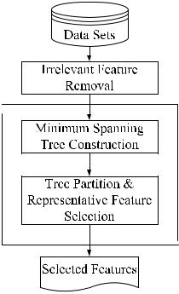
ability to the target concept. It is formally defined by Yu and

Liu [70] based on Markov blanket [36]. The definitions of

Markov blanket and redundant feature are introduced as
follows, respectively.

Definition 2. (Markov Blanket). Given a feature F_{i} 2 F , let
M_{i} F (F_{i} 62 M_{i}), M_{i} is said to be a Markov blanket for F_{i} if
and only if

pðF M_{i} fF_{i}g; C j F_{i}; M_{i}Þ ¼ pðF M_{i} fF_{i}g; C j M_{i}Þ:

Fig. 1. Framework of the proposed feature subset selection algorithm.

and redundant features, and obtain a good feature subset. We achieve this through a new feature selection framework (shown in Fig. 1) which composed of the two connected components of irrelevant feature removal and redundant feature elimination. The former obtains features relevant to the target concept by eliminating irrelevant ones, and the latter removes redundant features from relevant ones via choosing representatives from different feature clusters, and thus produces the final subset.

The irrelevant feature removal is straightforward once the right relevance measure is defined or selected, while the redundant feature elimination is a bit of sophisticated. In our proposed FAST algorithm, it involves 1) the construction of the minimum spanning tree from a weighted complete graph; 2) the partitioning of the MST into a forest with each tree representing a cluster; and 3) the selection of representative features from the clusters.

In order to more precisely introduce the algorithm, and because our proposed feature subset selection framework involves irrelevant feature removal and redundant feature elimination, we first present the traditional definitions of relevant and redundant features, then provide our defini-tions based on variable correlation as follows.

John et al. [33] presented a definition of relevant features. Suppose F to be the full set of features, F_{i} 2 F be a feature, S_{i} ¼ F fF_{i}g and S_{i}⁰ S_{i}. Let s⁰_{i} be a value-assignment of all features in S_{i}⁰, f_{i} a value-assignment of feature F_{i}, and c a value-assignment of the target concept C. The definition can be formalized as follows.

Definition 1 (Relevant Feature). F_{i} is relevant to the target concept C if and only if there exists some s⁰_{i}, f_{i}, and c, such that, for probability pðS_{i}⁰ ¼ s⁰_{i}; F_{i} ¼ f_{i}Þ > 0,

pðC ¼ c j S_{i}⁰ ¼ s⁰_{i}; F_{i} ¼ f_{i}Þ ¼6 pðC ¼ c j S_{i}⁰ ¼ s⁰_{i}Þ:

Otherwise, feature F_{i} is an irrelevant feature.

Definition 1 indicates that there are two kinds of relevant features due to different S_{i}⁰: 1) when S_{i}⁰ ¼ S_{i}, from the definition we can know that F_{i} is directly relevant to the target concept; 2) when S_{i}⁰ 6 S_{i}, from the definition we may

Definition 3 (Redundant Feature). Let S be a set of features, a feature in S is redundant if and only if it has a Markov Blanket within S.

Relevant features have strong correlation with target concept so are always necessary for a best subset, while redundant features are not because their values are com-pletely correlated with each other. Thus, notions of feature redundancy and feature relevance are normally in terms of feature correlation and feature-target concept correlation.

Mutual information measures how much the distribution of the feature values and target classes differ from statistical independence. This is a nonlinear estimation of correlation between feature values or feature values and target classes. The symmetric uncertainty (SU) [53] is derived from the mutual information by normalizing it to the entropies of feature values or feature values and target classes, and has been used to evaluate the goodness of features for classification by a number of researchers (e.g., Hall [29], Hall and Smith [30], Yu and Liu [68], [71], Zhao and Liu [72], [73]). Therefore, we choose symmetric uncertainty as the measure of correlation between either two features or a feature and the target concept.

The symmetric uncertainty is defined as follows:

SU | X; Y | Þ ¼ | 2 GainðXjY Þ |  | : | 1
ð |  | Þ ¼ | H X | H Y |  | ð Þ
 |  |  | ð Þ þ | ð Þ

Where,

- HðXÞ is the entropy of a discrete random variable X. Suppose pðxÞ is the prior probabilities for all values of X, HðXÞ is defined by

ð Þ ¼ | X | ð Þ | ð Þ | ð Þ
H X | X | p x | log₂ p x : | 2
 | x2X

- GainðXjY Þ is the amount by which the entropy of Y decreases. It reflects the additional information about Y provided by X and is called the information gain [55] which is given by

obtain that pðCjS_{i}; F_{i}Þ ¼ pðCjS_{i}Þ. It seems that F_{i} is irrelevant to the target concept. However, the definition shows that feature F_{i} is relevant when using S_{i}⁰ [ fF_{i}g to describe the

GainðXjY Þ ¼ HðXÞ HðXjY Þ ¼ HðY Þ HðY jXÞ:

ð3Þ

target concept. The reason behind is that either F_{i} is interactive with S_{i}⁰ or F_{i} is redundant with S_{i} S_{i}⁰. In this case, we say F_{i} is indirectly relevant to the target concept.

Most of the information contained in redundant features is already present in other features. As a result, redundant

Where HðXjY Þ is the conditional entropy which quantifies the remaining entropy (i.e., uncertainty) of a random variable X given that the value of another random variable Y is known. Suppose, pðxÞ is the prior probabilities for all values of X and pðxjyÞ is

4 IEEE TRANSACTIONS ON KNOWLEDGE AND DATA ENGINEERING, VOL. 25, NO. 1, JANUARY 2013

the posterior probabilities of X given the values of Y , HðXjY Þ is defined by

ð j Þ ¼ | X | ð Þ | X | ð j Þ | ð j Þ | ð Þ
H X Y | X | p y | X | p x y | log₂ p x y : | 4
 | y2Y |  | x2X

Information gain is a symmetrical measure. That is the amount of information gained about X after observing Y is equal to the amount of information gained about Y after observing X. This ensures that the order of two variables (e.g., ðX; Y Þ or ðY ; XÞ) will not affect the value of the measure.

Symmetric uncertainty treats a pair of variables symme-trically, it compensates for information gain’s bias toward variables with more values and normalizes its value to the range [0,1]. A value 1 of SUðX; Y Þ indicates that knowledge of the value of either one completely predicts the value of the other and the value 0 reveals that X and Y are independent. Although the entropy-based measure handles nominal or discrete variables, they can deal with continuous features as well, if the values are discretized properly in advance [20].

Given SUðX; Y Þ the symmetric uncertainty of variables

- and Y , the relevance T-Relevance between a feature and the target concept C, the correlation F-Correlation between a pair of features, the feature redundance F-Redundancy and the representative feature R-Feature of a feature cluster can be defined as follows.

Definition 4 (T-Relevance). The relevance between the feature F_{i} 2 F and the target concept C is referred to as the T-Relevance of F_{i} and C, and denoted by SUðF_{i}; CÞ.

If SUðF_{i}; CÞ is greater than a predetermined threshold , we say that F_{i} is a strong T-Relevance feature.

Definition 5 (F-Correlation). The correlation between any pair of features F_{i} and F_{j} ðF_{i}; F_{j} 2 F ^ i ¼6 jÞ is called the F-Correlation of F_{i} and F_{j}, and denoted by SUðF_{i}; F_{j}Þ.
Definition 6 (F-Redundancy). Let S ¼ fF₁; F₂; . . . ; F_{i}; . . . ;
F_{k<jF} _{j}g be a cluster of features. if 9F_{j} 2 S, SUðF_{j}; C Þ SUðF_{i}; CÞ ^ SUðF_{i}; F_{j}Þ > SUðF_{i}; CÞ is always corrected for

each F_{i} 2 S ði 6¼ jÞ, then F_{i} are redundant features with respect to the given F_{j} (i.e., each F_{i} is a F-Redundancy ).

Definition 7 (R-Feature). A feature F_{i} 2 S ¼ fF₁; F₂; . . . ; F_{k}g ðk < jF jÞ is a representative feature of the cluster S ( i.e., F_{i} is a R-Feature ) if and only if,

F_{i} ¼ argmax_{Fj2S}SUðF_{j}; CÞ.

This means the feature, which has the strongest T-Relevance, can act as a R-Feature for all the features in the cluster.

According to the above definitions, feature subset selection can be the process that identifies and retains the strong T-Relevance features and selects R-Features from feature clusters. The behind heuristics are that

- irrelevant features have no/weak correlation with target concept;

- redundant features are assembled in a cluster and a representative feature can be taken out of the cluster.

3.2 Algorithm and Analysis

The proposed FAST algorithm logically consists of three steps: 1) removing irrelevant features, 2) constructing an

Fig. 2. Example of the clustering step.
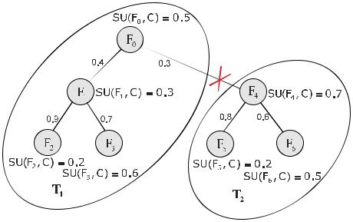

MST from relative ones, and 3) partitioning the MST and selecting representative features.

For a data set D with m features F ¼ fF₁; F₂; . . . ; F_{m}g and class C, we compute the T-Relevance SUðF_{i}; CÞ value for

each feature F_{i} ð1 i mÞ in the first step. The features whose SUðF_{i}; CÞ values are greater than a predefined threshold comprise the target-relevant feature subset
F ⁰ ¼ fF₁⁰; F₂⁰; . . . ; F_{k}⁰g ðk mÞ.
In the second step, we first calculate the F-Correlation SUðF_{i}⁰; F_{j}⁰Þ value for each pair of features F_{i}⁰ and F_{j}⁰

ðF_{i}⁰; F_{j}⁰ 2 F ⁰ ^ i 6¼ jÞ. Then, viewing features F_{i}⁰ and F_{j}⁰ as vertices and SUðF_{i}⁰; F_{j}⁰Þ ði ¼6 jÞ as the weight of the edge
between vertices F_{i}⁰ and F_{j}⁰, a weighted complete graph
G ¼ ðV ; EÞ is constructed where | V ¼ fF_{i}⁰ j F_{i}⁰ 2 F ⁰ ^ i 2
½1; k&g and E ¼ fðF_{i}⁰; F_{j}⁰ÞjðF_{i}⁰; F_{j}⁰ | 2 F ⁰ ^ i; j 2 ½1; k& ^ i ¼6 jg.
As symmetric uncertainty is symmetric further the |  | F-
Correlation SUðF_{i}⁰; F_{j}⁰Þ is symmetric as well, thus G is |  | an
undirected graph.

The complete graph G reflects the correlations among all the target-relevant features. Unfortunately, graph G has

- vertices and kðk 1Þ/2 edges. For high-dimensional data, it is heavily dense and the edges with different weights are strongly interweaved. Moreover, the decomposition of complete graph is NP-hard [26]. Thus for graph G, we build an MST, which connects all vertices such that the sum

of the weights of the edges is the minimum, using the well-known Prim algorithm [54]. The weight of edge ðF_{i}⁰; F_{j}⁰Þ is F-Correlation SUðF_{i}⁰; F_{j}⁰Þ.

After building the MST, in the third step, we first remove
the edges E ¼ fðF_{i}⁰; F_{j}⁰Þ j ðF_{i}⁰; F_{j}⁰ 2 F ⁰ ^ i; j 2 ½1; k& ^ i ¼6 jg, whose weights are smaller than both of the T-Relevance

SUðF_{i}⁰; CÞ and SUðF_{j}⁰; CÞ, from the MST. Each deletion results in two disconnected trees T₁ and T₂.
Assuming the set of vertices in any one of the final trees

to be V ðT Þ, we have the property that for each pair of
vertices ðF_{i}⁰; F_{j}⁰ 2 V ðT ÞÞ, SUðF_{i}⁰; F_{j}⁰ Þ SUðF_{i}⁰; CÞ _ SUðF_{i}⁰; F_{j}⁰Þ SUðF_{j}⁰; CÞ always holds. From Definition 6, we know

that this property guarantees the features in V ðT Þ are redundant.

This can be illustrated by an example. Suppose the MST shown in Fig. 2 is generated from a complete graph G. In order to cluster the features, we first traverse all the six edges, and then decide to remove the edge ðF₀; F₄Þ because its weight SUðF₀; F₄Þ ¼ 0:3 is smaller than both SU ðF₀; CÞ ¼ 0:5 and SUðF₄; C Þ ¼ 0:7. This makes the MST is clustered into two clusters denoted as V ðT₁ Þ and V ðT₂Þ. Each cluster is an MST as well. Take V ðT₁Þ as an example. From Fig. 2, we know that SUðF₀; F₁Þ > SUðF₁; CÞ, SUðF₁; F₂Þ > SUðF₁; CÞ ^ SUðF₁; F₂Þ > SU ðF₂; CÞ, SUðF₁; F₃Þ > SUðF₁; C Þ ^ SUðF₁; F₃Þ > SUðF₃; CÞ. We also observed that there is no edge exists between F₀ and F₂, F₀ and F₃, and F₂ and F₃.

SONG ET AL.: A FAST CLUSTERING-BASED FEATURE SUBSET SELECTION ALGORITHM FOR HIGH-DIMENSIONAL DATA | 5

Considering that T₁ is an MST, so the SUðF₀; F₂Þ is greater than SUðF₀; F₁Þ and SUðF₁; F₂Þ, SUðF₀; F₃Þ is greater than SUðF₀; F₁Þ and SUðF₁; F₃Þ, and SUðF₂; F₃Þ is greater than SUðF₁; F₂Þ and SUðF₂; F₃Þ. Thus, SUðF₀; F₂Þ > SUðF₀; CÞ^ SUðF₀; F₂Þ > SUðF₂; CÞ, SUðF₀; F₃Þ > SUðF₀; CÞ ^ SUðF₀; F₃Þ > SUðF₃; CÞ, and SUðF₂; F₃Þ > SUðF₂; CÞ ^ SUðF₂;

F₃Þ > SU ðF₃; CÞ also hold. As the mutual information between any pair ðF_{i}; F_{j} Þði; j ¼ 0; 1; 2; 3 ^ i ¼6 jÞ of F₀; F₁; F₂, and F₃ is greater than the mutual information between class C and F_{i} or F_{j}, features F₀; F₁; F₂, and F₃ are redundant.

After removing all the unnecessary edges, a forest Forest is obtained. Each tree T_{j} 2 Forest represents a cluster that is denoted as V ðT_{j}Þ, which is the vertex set of T_{j} as well. As illustrated above, the features in each cluster are redundant, so for each cluster V ðT_{j}Þ we choose a representative feature F_{R}^{j} whose T-Relevance SUðF_{R}^{j}; CÞ is the greatest. All F_{R}^{j} ðj ¼ 1 . . . jF orestjÞ comprise the final feature subset [F_{R}^{j}.
The details of the FAST algorithm is shown in Algorithm 1.

Algorithm 1. FAST
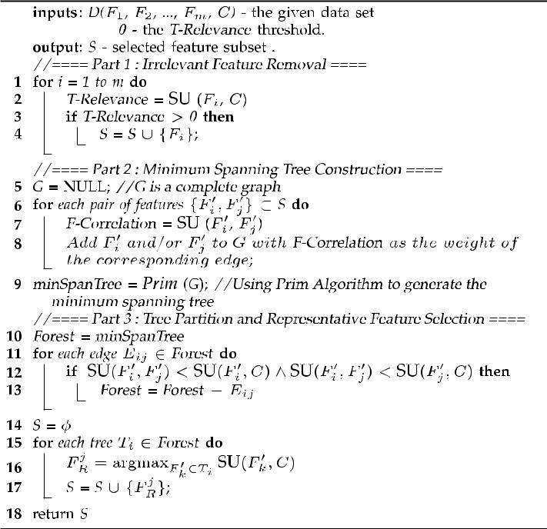

Time complexity analysis. The major amount of work for Algorithm 1 involves the computation of SU values for T-Relevance and F-Correlation, which has linear complexity in terms of the number of instances in a given data set. The first part of the algorithm has a linear time complexity OðmÞ in terms of the number of features m. Assuming kð1 k mÞ features are selected as relevant ones in the first part, when k ¼ 1, only one feature is selected. Thus, there is no need to continue the rest parts of the algorithm, and the complexity is OðmÞ. When 1 < k m, the second part of the algorithm first constructs a complete graph from relevant features and the complexity is Oðk²Þ, and then generates an MST from the graph using Prim algorithm whose time complexity is Oðk²Þ. The third part partitions the MST and chooses the represen-
tative features with the complexity of OðkÞ. Thus₂ |  |  |  |  |  |  |  |  | when
1 < k m, the complexity of the algorithm is Oðm þ k |  |  |  |  |  |  |  |  | Þ. This
means when | k |  | ^{ﬃﬃﬃﬃﬃ}, FAST has linear | 2 |  |  |  |  | ð |  | Þ
 | k |  | p_{m} | complexity |  |  |  |  | O |  | m ,
while obtains the worst complexity Oðm Þ when k ¼ m.
However, k is heuristically set to be b |  |  |  |  | ﬃﬃﬃﬃﬃ | lg | m | c in₂ |  | the
p |  |  |  |  | m |  | m |  |  | mÞ,
implementation of FAST. So the complexity is Oðm |  |  |  |  |  |  |  | lg

TABLE 1
Summary of the 35 Benchmark Data Sets
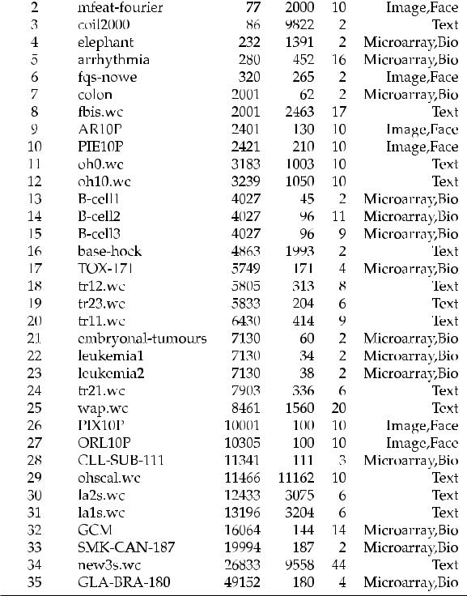

which is typically less than Oðm²Þ since lg²m < m. This can be explained as follows. Let fðmÞ ¼ m lg² m, so the derivative f⁰ðmÞ ¼ 1 2 lg e=m, which is greater than zero when m > 1. So fðmÞ is a increasing function and it is greater than fð1Þ which is equal to 1, i.e., m > lg² m, when m > 1. This means the bigger the m is, the farther the time complexity of FAST deviates from Oðm²Þ. Thus, on high-dimensional data, the time complexity of FAST is far more less than Oðm²Þ. This makes FAST has a better runtime performance with high-dimensional data as shown in Section 4.4.2.

- EMPIRICAL STUDY

4.1 Data Source

For the purposes of evaluating the performance and effectiveness of our proposed FAST algorithm, verifying whether or not the method is potentially useful in practice, and allowing other researchers to confirm our results, 35 publicly available data sets¹ were used.

The numbers of features of the 35 data sets vary from 37 to 49,52 with a mean of 7,874. The dimensionality of the 54.3 percent data sets exceed 5,000, of which 28.6 percent data sets have more than 10,000 features.

The 35 data sets cover a range of application domains such as text, image and bio microarray data classification. Table 1² shows the corresponding statistical information.

Note that for the data sets with continuous-valued features, the well-known off-the-shelf MDL method [74] was used to discretize the continuous values.

- The data sets can be downloaded at: http://archive.ics.uci.edu/ml/ http://tunedit.org/repo/Data/Text-wchttp://featureselection.asu.edu/ datasets.phphttp://www.lsi.us.es/aguilar/datasets.html.

- F, I, and T denote the number of features, the number of instances, and the number of classes, respectively.

6 IEEE TRANSACTIONS ON KNOWLEDGE AND DATA ENGINEERING, VOL. 25, NO. 1, JANUARY 2013

4.2 Experiment Setup

To evaluate the performance of our proposed FAST algo-rithm and compare it with other feature selection algorithms in a fair and reasonable way, we set up our experimental study as follows:

- The proposed algorithm is compared with five different types of representative feature selection algorithms. They are 1) FCBF [68], [71], 2) ReliefF [57], 3) CFS [29], 4) Consist [14], and 5) FOCUS-SF [2], respectively.

FCBF and ReliefF evaluate features individually.

For FCBF, in the experiments, we set the relevance threshold to be the SU value of the bm=log mc_{th} ranked feature for each data set (m is the number of features in a given data set) as suggested by Yu and Liu [68], [71]. ReliefF searches for nearest neighbors of instances of different classes and weights features according to how well they differentiate instances of different classes.

The other three feature selection algorithms are based on subset evaluation. CFS exploits best first search based on the evaluation of a subset that contains features highly correlated with the target concept, yet uncorrelated with each other. The Consist method searches for the minimal subset that separates classes as consistently as the full set can under best first search strategy. FOCUS-SF is a variation of FOCUS [2]. FOCUS has the same evaluation strategy as Consist, but it examines all subsets of features. Considering the time efficiency, FOUCS-SF replaces exhaustive search in FOCUS with sequential forward selection.

For our proposed FAST algorithm, we heuristi-pﬃﬃﬃﬃﬃ

cally set to be the SU value of the b m lg mc_{th} ranked feature for each data set.

- Four different types of classification algorithms are employed to classify data sets before and after feature selection. They are 1) the probability-based Naive Bayes (NB), 2) the tree-based C4.5, 3) the instance-based lazy learning algorithm IB1, and

  - the rule-based RIPPER, respectively.

Naive Bayes utilizes a probabilistic method for

classification by multiplying the individual prob-abilities of every feature-value pair. This algorithm assumes independence among the features and even then provides excellent classification results.

Decision tree learning algorithm C4.5 is an extension of ID3 that accounts for unavailable values, continuous attribute value ranges, pruning of decision trees, rule derivation, and so on. The tree comprises of nodes (features) that are selected by information entropy.

Instance-based learner IB1 is a single-nearest-neighbor algorithm, and it classifies entities taking the class of the closest associated vectors in the training set via distance metrics. It is the simplest among the algorithms used in our study.

Inductive rule learner Repeated Incremental Prun-ing to Produce Error Reduction (IRIPPER) [12] is a propositional rule learner that defines a rule-based detection model and seeks to improve it iteratively by

using different heuristic techniques. The constructed rule set is then used to classify new instances.

- When evaluating the performance of the feature subset selection algorithms, four metrics, 1) the proportion of selected features 2) the time to obtain the feature subset, 3) the classification accuracy, and

  - the Win/Draw/Loss record [65], are used.

The proportion of selected features is the ratio of

the number of features selected by a feature selection algorithm to the original number of features of a data set.

The Win/Draw/Loss record presents three va-lues on a given measure, i.e., the numbers of data sets for which our proposed algorithm FAST obtains better, equal, and worse performance than other five feature selection algorithms, respectively. The mea-sure can be the proportion of selected features, the runtime to obtain a feature subset, and the classifica-tion accuracy, respectively.

4.3 Experimental Procedure

In order to make the best use of the data and obtain stable results, a ðM ¼ 5Þ ðN ¼ 10Þ-cross-validation strategy is used. That is, for each data set, each feature subset selection algorithm and each classification algorithm, the 10-fold cross-validation is repeated M = 5 times, with each time the order of the instances of the data set being randomized. This is because many of the algorithms exhibit order effects, in that certain orderings dramatically improve or degrade performance [21]. Randomizing the order of the inputs can help diminish the order effects.

In the experiment, for each feature subset selection algorithm, we obtain M N feature subsets Subset and the corresponding runtime Time with each data set. Average jSubsetj and Time, we obtain the number of selected features further the proportion of selected features and the corre-sponding runtime for each feature selection algorithm on each data set. For each classification algorithm, we obtain M N classification Accuracy for each feature selection algorithm and each data set. Average these Accuracy, we obtain mean accuracy of each classification algorithm under each feature selection algorithm and each data set. The procedure Experimental Process shows the details.

Procedure Experimental Process
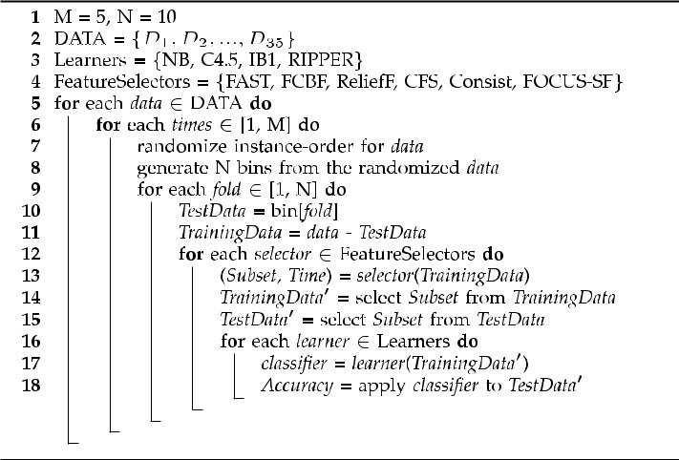

SONG ET AL.: A FAST CLUSTERING-BASED FEATURE SUBSET SELECTION ALGORITHM FOR HIGH-DIMENSIONAL DATA | 7
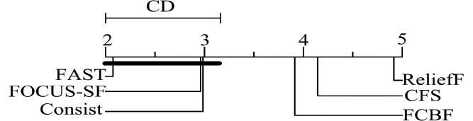

TABLE 2
Proportion of Selected Features of the Six Feature
Selection Algorithms

4.4 Results and Analysis
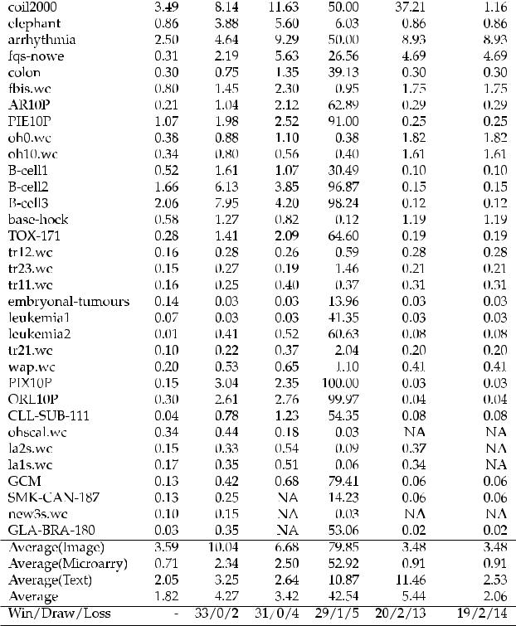

In this section, we present the experimental results in terms of the proportion of selected features, the time to obtain the feature subset, the classification accuracy, and the Win/ Draw/Loss record.

For the purpose of exploring the statistical significance of the results, we performed a nonparametric Friedman test

- followed by Nemenyi posthoc test [47], as advised by Demsar [17] and Garcia and Herrerato [25] to statistically compare algorithms on multiple data sets. Thus, the Friedman and the Nemenyi test results are reported as well.

4.4.1 Proportion of Selected Features

Table 2 records the proportion of selected features of the six feature selection algorithms for each data set. From it we observe that

- Generally all the six algorithms achieve significant reduction of dimensionality by selecting only a small portion of the original features. The FAST, on average, obtains the best proportion of selected features of 1.82 percent. The Win/Draw/Loss records show FAST wins other algorithms as well.

- For image data, the proportion of selected features of each algorithm has an increment compared with the corresponding average proportion of selected features on the given data sets except Consist has an improvement. This reveals that the five algorithms are not very suitable to choose features for image data compared with for microarray and text data. FAST ranks 3 with the proportion of selected

Fig. 3. Proportion of selected features comparison of all feature selection algorithms against each other with the Nemenyi test.

features of 3.59 percent that has a tiny margin of 0.11 percent to the first and second best proportion of selected features 3.48 percent of Consist and FOCUS-SF, and a margin of 76.59 percent to the worst proportion of selected features 79.85 percent of ReliefF.

- For microarray data, the proportion of selected features has been improved by each of the six algorithms compared with that on the given data sets. This indicates that the six algorithms work well with microarray data. FAST ranks 1 again with the proportion of selected features of 0.71 percent. Of the six algorithms, only CFS cannot choose features for two data sets whose dimensionalities are 19,994 and 49,152, respectively.

- For text data, FAST ranks 1 again with a margin of 0.48 percent to the second best algorithm FOCUS-SF.

The Friedman test [24] can be used to compare

- algorithms over N data sets by ranking each algorithm on each data set separately. The algorithm obtained the best performance gets the rank of 1, the second best ranks 2, and so on. In case of ties, average ranks are assigned. Then, the average ranks of all algorithms on all data sets are calculated and compared. If the null hypothesis, which is all algorithms are performing equivalently, is rejected under the Friedman test statistic, posthoc tests such as the Nemenyi test [47] can be used to determine which algorithms perform statistically different.

The Nemenyi test compares classifiers in a pairwise manner. According to this test, the performances of two

classifiers are significantly different if the distance of the qﬃﬃﬃﬃﬃﬃﬃﬃﬃﬃﬃ
average ranks exceeds the critical distance CD ¼ q ^{kðkþ1Þ},

6N

where the q is based on the Studentized range statistic [48] pﬃﬃﬃ

divided by 2.

In order to further explore whether the reduction rates are significantly different we performed a Friedman test followed by a Nemenyi posthoc test.

The null hypothesis of the Friedman test is that all the feature selection algorithms are equivalent in terms of proportion of selected features. The test result is p = 0. This means that at ¼ 0:1, there is evidence to reject the null hypothesis and all the six feature selection algorithms are different in terms of proportion of selected features.

In order to further explore feature selection algorithms whose reduction rates have statistically significant differ-ences, we performed a Nemenyi test. Fig. 3 shows the results with ¼ 0:1 on the 35 data sets. The results indicate that the proportion of selected features of FAST is statistically smaller than those of RelieF, CFS, and FCBF, and there is no consistent evidence to indicate statistical differences between FAST , Consist, and FOCUS-SF, respectively.

8 |  | IEEE TRANSACTIONS ON KNOWLEDGE AND DATA ENGINEERING, VOL. 25, NO. 1, JANUARY 2013
 |  | TABLE 3 |  |  | TABLE 4
 | Runtime (in ms) of the Six Feature Selection Algorithms |  |  | Accuracy of Naive Bayes with the
 |  |  |  | Six Feature Selection Algorithms
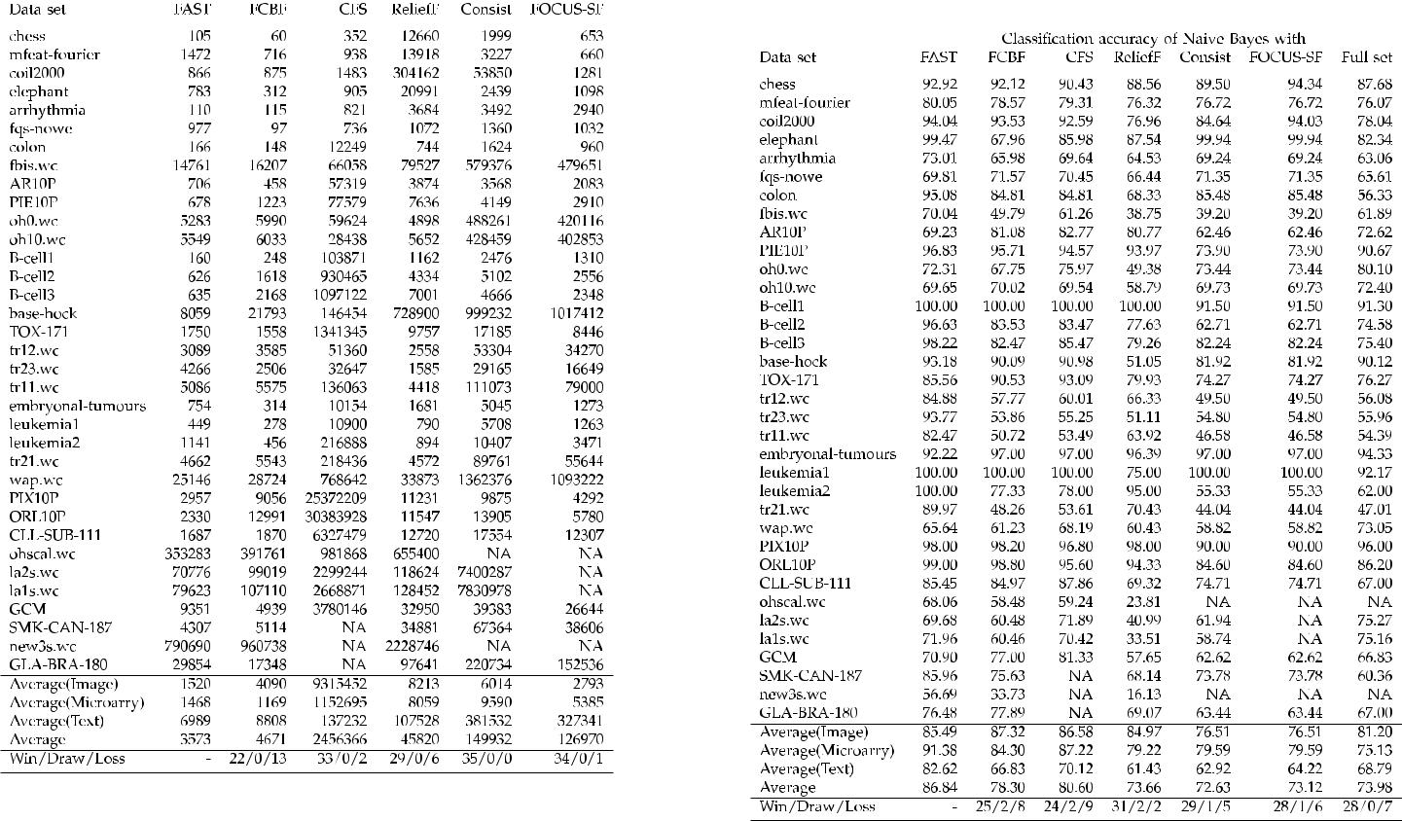

4.4.2 Runtime

Table 3 records the runtime of the six feature selection algorithms. From it we observe that

- Generally the individual evaluation-based feature selection algorithms of FAST, FCBF, and ReliefF are much faster than the subset evaluation based algo-rithms of CFS, Consist, and FOCUS-SF. FAST is consistently faster than all other algorithms. The runtime of FAST is only 0.1 percent of that of CFS, 2.4 percent of that of Consist, 2.8 percent of that of FOCUS-SF, 7.8 percent of that of ReliefF, and 76.5 percent of that of FCBF, respectively. The Win/ Draw/Loss records show that FAST outperforms other algorithms as well.

- For image data, FAST obtains the rank of 1. Its runtime is only 0.02 percent of that of CFS, 18.50 percent of that of ReliefF, 25.27 percent of that of Consist, 37.16 percent of that of FCBF, and 54.42 percent of that of FOCUS-SF, respectively. This reveals that FAST is more efficient than others when choosing features for image data.

- For microarray data, FAST ranks 2. Its runtime is only 0.12 percent of that of CFS, 15.30 percent of that of Consist, 18.21 percent of that of ReliefF, 27.25 percent of that of FOCUS-SF, and 125.59 per-cent of that of FCBF, respectively.
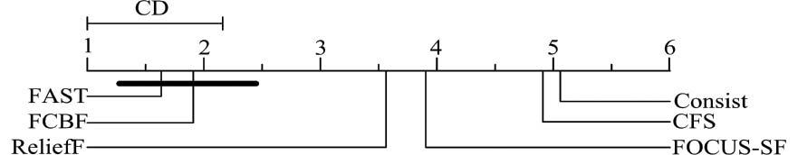

- For text data, FAST ranks 1. Its runtime is 1.83 per-cent of that of Consist, 2.13 percent of that of FOCUS-SF, 5.09 percent of that of CFS, 6.50 percent of that of ReliefF, and 79.34 percent of that of FCBF, respectively. This indicates that FAST is more efficient than others when choosing features for text data as well.

In order to further explore whether the runtime of the six feature selection algorithms are significantly different we performed a Friedman test. The null hypothesis of the Friedman test is that all the feature selection algorithms are equivalent in terms of runtime. The test result is p = 0. This means that at ¼ 0:1, there is evidence to reject the null hypothesis and all the six feature selection algorithms are different in terms of runtime. Thus a posthoc Nemenyi test was conducted. Fig. 4 shows the results with ¼ 0:1 on the 35 data sets. The results indicate that the runtime of FAST is statistically better than those of ReliefF, FOCUS-SF, CFS, and Consist, and there is no consistent evidence to indicate statistical runtime differences between FAST and FCBF.

4.4.3 Classification Accuracy

Tables 4, 5, 6, and 7 show the 10-fold cross-validation accuracies of the four different types of classifiers on the 35 data sets before and after each feature selection algorithm is performed, respectively.

Table 4 shows the classification accuracy of Naive Bayes. From it we observe that

Fig. 4. Runtime comparison of all feature selection algorithms against each other with the Nemenyi test.

- Compared with original data, the classification accuracy of Naive Bayes has been improved by FAST,

SONG ET AL.: A FAST CLUSTERING-BASED FEATURE SUBSET SELECTION ALGORITHM FOR HIGH-DIMENSIONAL DATA |  |  |  |  |  |  | 9
 |  | TABLE 5 |  |  |  | TABLE 7
Accuracy of C4.5 with the Six Feature Selection Algorithms |  |  |  | Accuracy of RIPPER with the Six Feature Selection Algorithms
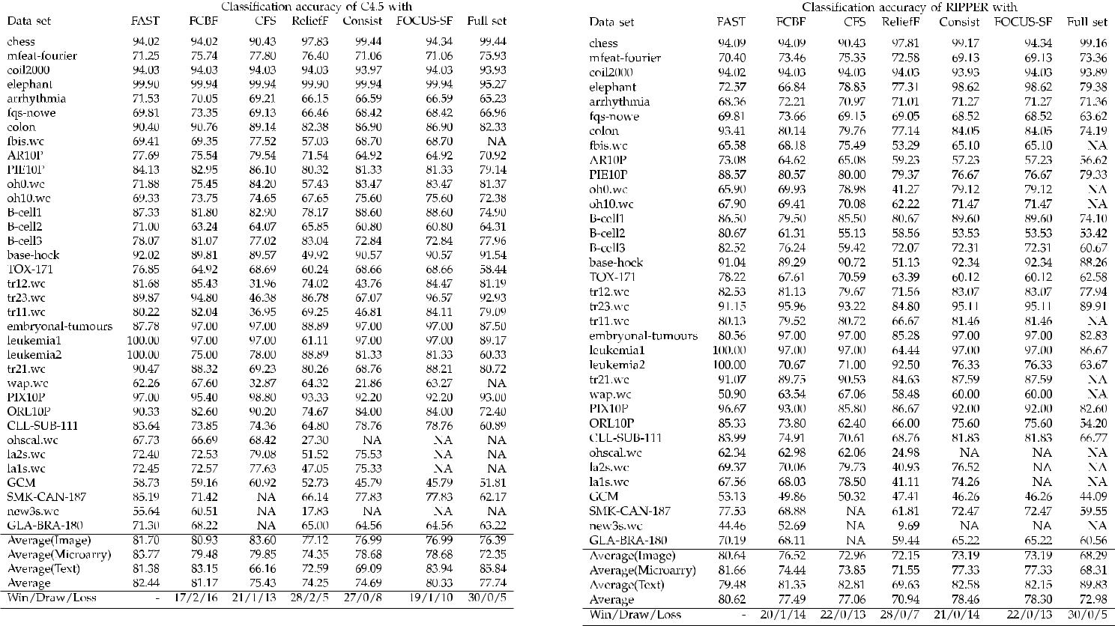

CFS, and FCBF by 12.86, 6.62, and 4.32 percent, respectively. Unfortunately, ReliefF, Consist, and FOCUS-SF have decreased the classification accuracy by 0.32, 1.35, and 0.86 percent, respectively. FAST

TABLE 6
Accuracy of IB1 with the Six Feature Selection Algorithms
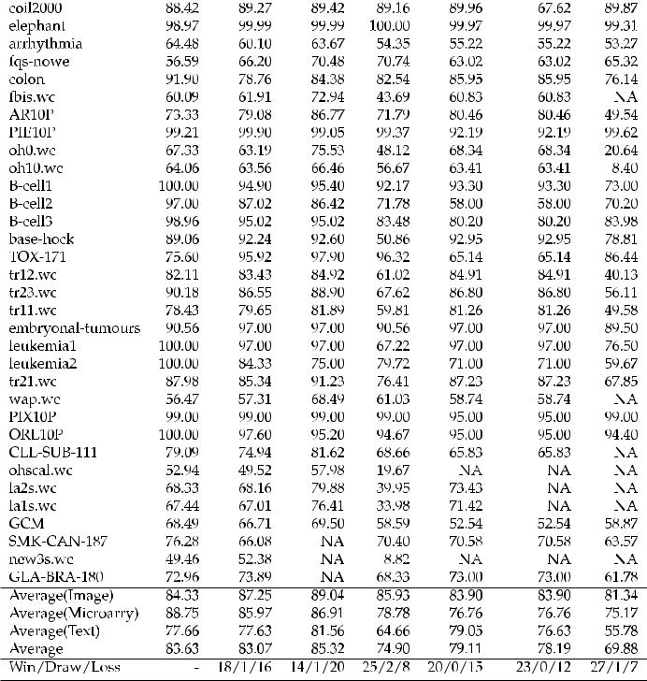

ranks 1 with a margin of 6.24 percent to the second best accuracy 80.60 percent of CFS. At the same time, the Win/Draw/Loss records show that FAST out-performs all other five algorithms.

- For image data, the classification accuracy of Naive Bayes has been improved by FCBF, CFS, FAST, and ReliefF by 6.13, 5.39, 4.29, and 3.78 percent, respec-tively. However, Consist and FOCUS-SF have decreased the classification accuracy by 4.69 and 4.69 percent, respectively. This time FAST ranks 3 with a margin of 1.83 percent to the best accuracy 87.32 percent of FCBF.

- For microarray data, the classification accuracy of Naive Bayes has been improved by all the six algorithms FAST, CFS, FCBF, ReliefF, Consist, and FOCUS-SF by 16.24, 12.09, 9.16, 4.08, 4.45, and 4.45 percent, respectively. FAST ranks 1 with a margin of 4.16 percent to the second best accuracy 87.22 percent of CFS. This indicates that FAST is more effective than others when using Naive Bayes to classify microarray data.

- For text data, FAST and CFS have improved the classification accuracy of Naive Bayes by 13.83 and 1.33 percent, respectively. Other four algorithms ReliefF, Consist, FOCUS-SF, and FCBF have de-creased the accuracy by 7.36, 5.87, 4.57, and 1.96 percent, respectively. FAST ranks 1 with a margin of 12.50 percent to the second best accuracy 70.12 percent of CFS.

Table 5 shows the classification accuracy of C4.5. From it we observe that

10 IEEE TRANSACTIONS ON KNOWLEDGE AND DATA ENGINEERING, VOL. 25, NO. 1, JANUARY 2013

- Compared with original data, the classification accuracy of C4.5 has been improved by FAST, FCBF, and FOCUS-SF by 4.69, 3.43, and 2.58 percent, respectively. Unfortunately, ReliefF, Consist, and CFS have decreased the classification accuracy by 3.49, 3.05, and 2.31 percent, respectively. FAST obtains the rank of 1 with a margin of 1.26 percent to the second best accuracy 81.17 percent of FCBF.

- For image data, the classification accuracy of C4.5 has been improved by all the six feature selection algorithms FAST, FCBF, CFS, ReliefF, Consist, and FOCUS-SF by 5.31, 4.5, 7.20, 0.73, 0.60, and 0.60 percent, respectively. This time FAST ranks 2 with a margin of 1.89 percent to the best accuracy 83.6 percent of CFS and a margin of 4.71 percent to the worst accuracy 76.99 percent of Consist and FOCUS-SF.

- For microarray data, the classification accuracy of C4.5 has been improved by all the six algorithms FAST, FCBF, CFS, ReliefF, Consist, and FOCUS-SF by 11.42, 7.14, 7.51, 2.00, 6.34, and 6.34 percent, respec-tively. FAST ranks 1 with a margin of 3.92 percent to the second best accuracy 79.85 percent of CFS.

- For text data, the classification accuracy of C4.5 has been decreased by algorithms FAST, FCBF, CFS, ReliefF, Consist, and FOCUS-SF by 4.46, 2.70, 19.68, 13.25, 16.75, and 1.90 percent, respectively. FAST ranks 3 with a margin of 2.56 percent to the best accuracy 83.94 percent of FOCUS-SF and a margin of 15.22 percent to the worst accuracy 66.16 percent of CFS.

Table 6 shows the classification accuracy of IB1. From it we observe that

- Compared with original data, the classification accuracy of IB1 has been improved by all the six feature selection algorithms FAST, FCBF, CFS, ReliefF, Consist, and FOCUS-SF by 13.75, 13.19, 15.44, 5.02, 9.23, and 8.31 percent, respectively. FAST ranks 2 with a margin of 1.69 percent to the best accuracy 85.32 percent of CFS. The Win/Draw/Loss records show that FAST outperforms all other algorithms except for CFS, winning and losing on 14 and 20 out of the 35 data sets, respectively.

Although FAST does not perform better than CFS, we observe that CFS is not available on the three biggest data sets of the 35 data sets. Moreover, CFS is very slow compared with other algorithms as reported in Section 4.4.2.

- For image data, the classification accuracy of IB1 has been improved by all the six feature selection algorithms FAST, FCBF, CFS, ReliefF, Consist, and FOCUS-SF by 3.00, 5.91, 7.70, 4.59, 2.56, and 2.56 percent, respectively. FAST ranks 4 with a margin of 4.70 percent to the best accuracy 89.04 percent of CFS.

- For microarray data, the classification accuracy of IB1 has been improved by all the six algorithms FAST, FCBF, CFS, ReliefF, Consist, and FOCUS-SF by 13.58, 10.80, 11.74, 3.61, 1.59, and 1.59 percent, respectively. FAST ranks 1 with a margin of 1.85 percent to the second best accuracy 86.91 percent of CFS and a

Fig. 5. Accuracy comparison of Naive Bayes with the six feature selection algorithms against each other with the Nemenyi test.
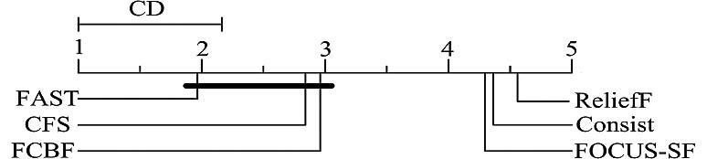

margin of 11.99 percent to the worst accuracy 76.76 percent of Consist and FOCUS-SF.

- For text data, the classification accuracy of IB1 has been improved by the five feature selection algorithms FAST, FCBF, CFS, ReliefF, Consist, and FOCUS-SF by 21.89, 21.85, 25.78, 8.88, 23.27, and 20.85 percent, respectively. FAST ranks 3 with a margin of 3.90 per-cent to the best accuracy 81.56 percent of CFS.

Table 7 shows the classification accuracy of RIPPER. From it we observe that

- Compared with original data, the classification accuracy of RIPPER has been improved by the five feature selection algorithms FAST, FCBF, CFS, Con-sist, and FOCUS-SF by 7.64, 4.51, 4.08, 5.48, and 5.32 percent, respectively; and has been decreased by ReliefF by 2.04 percent. FAST ranks 1 with a margin of 2.16 percent to the second best accuracy 78.46 percent of Consist. The Win/Draw/Loss records show that FAST outperforms all other algorithms.

- For image data, the classification accuracy of RIPPER has been improved by all the six feature selection algorithms FAST, FCBF, CFS, ReliefF, Consist, and FOCUS-SF by 12.35, 8.23, 4.67, 3.86, 4.90, and 4.90 percent, respectively. FAST ranks 1 with a margin of 4.13 percent to the second best accuracy 76.52 percent of FCBF.

- For microarray data, the classification accuracy of RIPPER has been improved by all the six algorithms FAST, FCBF, CFS, ReliefF, Consist, and FOCUS-SF by 13.35, 6.13, 5.54, 3.23, 9.02, and 9.02 percent, respec-tively. FAST ranks 1 with a margin of 4.33 percent to the second best accuracy 77.33 percent of Consist and FOCUS-SF.

- For text data, the classification accuracy of RIPPER has been decreased by FAST, FCBF, CFS, ReliefF, Consist, and FOCUS-SF by 10.35, 8.48, 7.02, 20.21, 7.25, and 7.68 percent, respectively. FAST ranks 5 with a margin of 3.33 percent to the best accuracy 82.81 percent of CFS.

In order to further explore whether the classification accuracies of each classifier with the six feature selection algorithms are significantly different, we performed four Friedman tests individually. The null hypotheses are that the accuracies are equivalent for each of the four classifiers with the six feature selection algorithms. The test results are

- = 0. This means that at ¼ 0:1, there are evidences to reject the null hypotheses and the accuracies are different further differences exist in the six feature selection algorithms. Thus four posthoc Nemenyi tests were conducted. Figs. 5, 6, 7,

and 8 show the results with ¼ 0:1 on the 35 data sets. From Fig. 5, we observe that the accuracy of Naive Bayes

with FAST is statistically better than those with ReliefF,

SONG ET AL.: A FAST CLUSTERING-BASED FEATURE SUBSET SELECTION ALGORITHM FOR HIGH-DIMENSIONAL DATA | 11

Fig. 6. Accuracy comparison of C4.5 with the six feature selection Fig. 8. Accuracy comparison of RIPPER with the six feature selection
algorithms against each other with the Nemenyi test. algorithms against each other with the Nemenyi test.
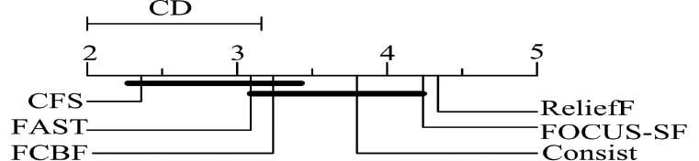

Fig. 7. Accuracy comparison of IB1 with the six feature selection algorithms against each other with the Nemenyi test.

Consist, and FOCUS-SF. But there is no consistent evidence to indicate statistical accuracy differences between Naive Bayes with FAST and with CFS, which also holds for Naive Bayes with FAST and with FCBF.

From Fig. 6, we observe that the accuracy of C4.5 with FAST is statistically better than those with ReliefF, Consist, and FOCUS-SF. But there is no consistent evidence to indicate statistical accuracy differences between C4.5 with FAST and with FCBF, which also holds for C4.5 with FAST and with CFS.

From Fig. 7, we observe that the accuracy of IB1 with FAST is statistically better than those with ReliefF. But there is no consistent evidence to indicate statistical accuracy differences between IB1 with FAST and with FCBF, Consist, and FOCUS-SF, respectively, which also holds for IB1 with FAST and with CFS.

From Fig. 8, we observe that the accuracy of RIPPER with FAST is statistically better than those with ReliefF. But there is no consistent evidence to indicate statistical accuracy differences between RIPPER with FAST and with FCBF, CFS, Consist, and FOCUS-SF, respectively.

For the purpose of exploring the relationship between feature selection algorithms and data types, i.e., which algorithms are more suitable for which types of data, we rank the six feature selection algorithms according to the classification accuracy of a given classifier on a specific type of data after the feature selection algorithms are performed. Then, we summarize the ranks of the feature selection algorithms under the four different classifiers, and give the final ranks of the feature selection algorithms on different types of data. Table 8 shows the results.

From Table 8, we observe that

- For image data, CFS obtains the rank of 1, and FAST ranks 3.

- For microarray data, FAST ranks 1 and should be the undisputed first choice, and CFS is a good alternative.

- For text data, CFS obtains the rank of 1, and FAST and FCBF are alternatives.

- For all data, FAST ranks 1 and should be the undisputed first choice, and FCBF, CFS are good alternatives.

From the analysis above we can know that FAST performs very well on the microarray data. The reason lies in both the characteristics of the data set itself and the property of the proposed algorithm.

Microarray data has the nature of the large number of features (genes) but small sample size, which can cause “curse of dimensionality” and overfitting of the training data

- In the presence of hundreds or thousands of features, researchers notice that it is common that a large number of features are not informative because they are either irrelevant or redundant with respect to the class concept

- Therefore, selecting a small number of discriminative genes from thousands of genes is essential for successful sample classification [27], [66].

Our proposed FAST effectively filters out a mass of irrelevant features in the first step. This reduces the possibility of improperly bringing the irrelevant features into the subsequent analysis. Then, in the second step, FAST removes a large number of redundant features by choosing a single representative feature from each cluster of redundant features. As a result, only a very small number of discriminative features are selected. This coincides with the desire happens of the microarray data analysis.

4.4.4 Sensitivity Analysis

Like many other feature selection algorithms, our proposed FAST also requires a parameter that is the threshold of feature relevance. Different values might end with different classification results.

In order to explore which parameter value results in the best classification accuracy for a specific classification problem with a given classifier, a 10-fold cross-validation strategy was employed to reveal how the classification accuracy is changing with value of the parameter .

Fig. 9 shows the results where the 35 subfigures represent the 35 data sets, respectively. In each subfigure, the four curves denotes the classification accuracies of the four classifiers with the different values. The cross points

TABLE 8
Rank of the Six Feature Selection Algorithms under Different Types of Data

12 IEEE TRANSACTIONS ON KNOWLEDGE AND DATA ENGINEERING, VOL. 25, NO. 1, JANUARY 2013
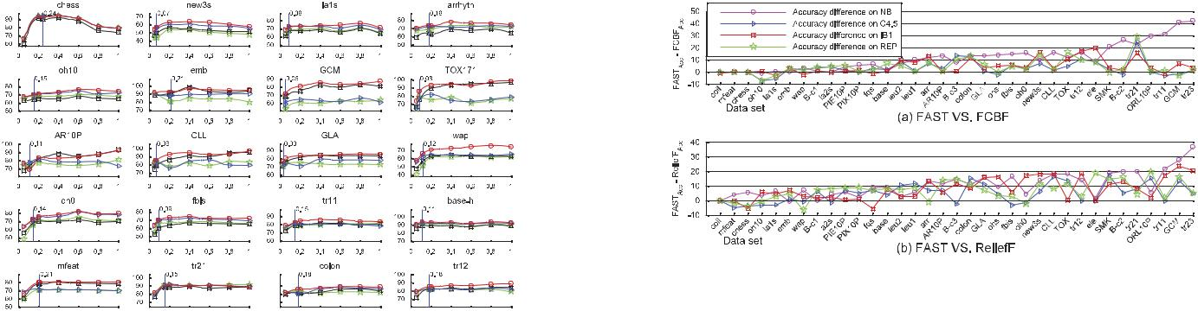

Fig. 10. Accuracy differences between FAST and the comparing
algorithms.
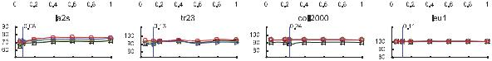

Fig. 9. Accuracies of the four classification algorithms with different values.
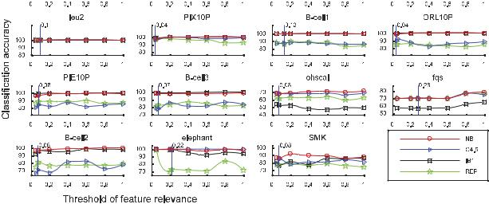

of the vertical line with the horizontal axis represent the default values of the parameter recommended by FAST, and the cross points of the vertical line with the four curves are the classification accuracies of the corresponding classifiers with the values. From it we observe that

- Generally, for each of the four classification algo-rithms, 1) different values result in different classification accuracies; 2) there is a value where the corresponding classification accuracy is the best; and 3) the values, in which the best classification accuracies are obtained, are different for both the different data sets and the different classification algorithms. Therefore, an appropriate value is desired for a specific classification problem and a given classification algorithm.

- In most cases, the default values recommended by FAST are not the optimal. Especially, in a few cases (e. g., data sets GCM, CLL-SUB-11, and TOX-171), the corresponding classification accuracies are very small. This means the results presented in Section 4.4.3 are not the best, and the performance could be better.

- For each of the four classification algorithms, although the values where the best classification accuracies are obtained are different for different data sets, The value of 0.2 is commonly accepted because the corresponding classification accuracies are among the best or nearly the best ones.

When determining the value of , besides classification accuracy, the proportion of the selected features should be taken into account as well. This is because improper proportion of the selected features results in a large number of features are retained, and further affects the classification efficiency.

Just like the default values used for FAST in the experiments are often not the optimal in terms of classifica-tion accuracy, the default threshold values used for FCBF

and ReliefF (CFS, Consist, and FOCUS-SF do not require any input parameter) could be so. In order to explore whether or not FAST still outperforms when optimal threshold values are used for the comparing algorithms, 10-fold cross-validation methods were first used to deter-mine the optimal threshold values and then were employed to conduct classification for each of the four classification methods with the different feature subset selection algo-rithms upon the 35 data sets. The results reveal that FAST still outperforms both FCBF and ReliefF for all the four classification methods, Fig. 10 shows the full details. At the same time, Wilcoxon signed ranks tests [75] with ¼ 0:05 were performed to confirm the results as advised by Demsar [76]. All the p values are smaller than 0.05, this indicates that the FAST is significantly better than both FCBF and ReliefF (please refer to Table 9 for details).

Note that the optimal value can be obtained via the cross-validation method. Unfortunately, it is very time consuming.

- CONCLUSION

In this paper, we have presented a novel clustering-based feature subset selection algorithm for high dimensional data. The algorithm involves 1) removing irrelevant features, 2) constructing a minimum spanning tree from relative ones, and 3) partitioning the MST and selecting representative features. In the proposed algorithm, a cluster consists of features. Each cluster is treated as a single feature and thus dimensionality is drastically reduced.

We have compared the performance of the proposed algorithm with those of the five well-known feature selection algorithms FCBF, ReliefF, CFS, Consist, and FOCUS-SF on the 35 publicly available image, microarray, and text data from the four different aspects of the proportion of selected features, runtime, classification accuracy of a given classifier, and the Win/Draw/Loss record. Generally, the proposed algorithm obtained the best proportion of selected features, the best runtime, and the best classification accuracy for Naive Bayes, C4.5, and RIPPER, and the second best classification accuracy for IB1. The Win/Draw/Loss records confirmed the conclusions.

TABLE 9
- Values of the Wilcoxon Tests

SONG ET AL.: A FAST CLUSTERING-BASED FEATURE SUBSET SELECTION ALGORITHM FOR HIGH-DIMENSIONAL DATA | 13

We also found that FAST obtains the rank of 1 for microarray data, the rank of 2 for text data, and the rank of 3 for image data in terms of classification accuracy of the four different types of classifiers, and CFS is a good alternative. At the same time, FCBF is a good alternative for image and text data. Moreover, Consist, and FOCUS-SF are alterna-tives for text data.

For the future work, we plan to explore different types of correlation measures, and study some formal properties of feature space.

ACKNOWLEDGMENTS

The authors would like to the editors and the anonymous reviewers for their insightful and helpful comments and suggestions, which resulted in substantial improvements to this work. This work is supported by the National Natural Science Foundation of China under grant 61070006.

REFERENCES

- H. Almuallim and T.G. Dietterich, “Algorithms for Identifying Relevant Features,” Proc. Ninth Canadian Conf. Artificial Intelligence, pp. 38-45, 1992.

- H. Almuallim and T.G. Dietterich, “Learning Boolean Concepts in the Presence of Many Irrelevant Features,” Artificial Intelligence, vol. 69, nos. 1/2, pp. 279-305, 1994.

- A. Arauzo-Azofra, J.M. Benitez, and J.L. Castro, “A Feature Set Measure Based on Relief,” Proc. Fifth Int’l Conf. Recent Advances in Soft Computing, pp. 104-109, 2004.

- L.D. Baker and A.K. McCallum, “Distributional Clustering of Words for Text Classification,” Proc. 21st Ann. Int’l ACM SIGIR Conf. Research and Development in information Retrieval, pp. 96-103, 1998.

- R. Battiti, “Using Mutual Information for Selecting Features in Supervised Neural Net Learning,” IEEE Trans. Neural Networks, vol. 5, no. 4, pp. 537-550, July 1994.

- D.A. Bell and H. Wang, “A Formalism for Relevance and Its Application in Feature Subset Selection,” Machine Learning, vol. 41, no. 2, pp. 175-195, 2000.

- J. Biesiada and W. Duch, “Features Election for High-Dimensional data a Pearson Redundancy Based Filter,” Advances in Soft Computing, vol. 45, pp. 242-249, 2008.

- R. Butterworth, G. Piatetsky-Shapiro, and D.A. Simovici, “On Feature Selection through Clustering,” Proc. IEEE Fifth Int’l Conf. Data Mining, pp. 581-584, 2005.

- C. Cardie, “Using Decision Trees to Improve Case-Based Learn-ing,” Proc. 10th Int’l Conf. Machine Learning, pp. 25-32, 1993.

- P. Chanda, Y. Cho, A. Zhang, and M. Ramanathan, “Mining of Attribute Interactions Using Information Theoretic Metrics,” Proc. IEEE Int’l Conf. Data Mining Workshops, pp. 350-355, 2009.

- S. Chikhi and S. Benhammada, “ReliefMSS: A Variation on a Feature Ranking Relieff Algorithm,” Int’l J. Business Intelligence and Data Mining, vol. 4, nos. 3/4, pp. 375-390, 2009.

- W. Cohen, “Fast Effective Rule Induction,” Proc. 12th Int’l Conf. Machine Learning (ICML ’95), pp. 115-123, 1995.

- M. Dash and H. Liu, “Feature Selection for Classification,” Intelligent Data Analysis, vol. 1, no. 3, pp. 131-156, 1997.

- M. Dash, H. Liu, and H. Motoda, “Consistency Based Feature Selection,” Proc. Fourth Pacific Asia Conf. Knowledge Discovery and Data Mining, pp. 98-109, 2000.

- S. Das, “Filters, Wrappers and a Boosting-Based Hybrid for Feature Selection,” Proc. 18th Int’l Conf. Machine Learning, pp. 74-81, 2001.

- M. Dash and H. Liu, “Consistency-Based Search in Feature Selection,” Artificial Intelligence, vol. 151, nos. 1/2, pp. 155-176, 2003.

- J. Demsar, “Statistical Comparison of Classifiers over Multiple Data Sets,” J. Machine Learning Res., vol. 7, pp. 1-30, 2006.

- I.S. Dhillon, S. Mallela, and R. Kumar, “A Divisive Information Theoretic Feature Clustering Algorithm for Text Classification,”
J. Machine Learning Research, vol. 3, pp. 1265-1287, 2003.

- E.R. Dougherty, “Small Sample Issues for Microarray-Based Classification,” Comparative and Functional Genomics, vol. 2, no. 1,
  - 28-34, 2001.

- U. Fayyad and K. Irani, “Multi-Interval Discretization of Con-tinuous-Valued Attributes for Classification Learning,” Proc. 13th Int’l Joint Conf. Artificial Intelligence, pp. 1022-1027, 1993.

- D.H. Fisher, L. Xu, and N. Zard, “Ordering Effects in Clustering,”
Proc. Ninth Int’l Workshop Machine Learning, pp. 162-168, 1992.

- F. Fleuret, “Fast Binary Feature Selection with Conditional Mutual Information,” J. Machine Learning Research, vol. 5, pp. 1531-1555, 2004.

- G. Forman, “An Extensive Empirical Study of Feature Selection Metrics for Text Classification,” J. Machine Learning Research, vol. 3,
  - 1289-1305, 2003.

- M. Friedman, “A Comparison of Alternative Tests of Significance for the Problem of m Ranking,” Annals of Math. Statistics, vol. 11,
  - 86-92, 1940.

- S. Garcia and F. Herrera, “An Extension on Statistical Compar-isons of Classifiers over Multiple Data Sets for All Pairwise Comparisons,” J. Machine Learning Res., vol. 9, pp. 2677-2694, 2008.

- M.R. Garey and D.S. Johnson, Computers and Intractability: A Guide to the Theory of NP-Completeness. W.H. Freeman & Co, 1979.

- T.R. Golub, D.K. Slonim, P. Tamayo, C. Huard, M. Gaasenbeek, J.P. Mesirov, H. Coller, M.L. Loh, J.R. Downing, and M.A. Caligiuri, “Molecular Classification of Cancer: Class Discovery and Class Prediction by Gene Expression Monitoring,” Science, vol. 286, no. 5439, pp. 531-537, 1999.

- I. Guyon and A. Elisseeff, “An Introduction to Variable and Feature Selection,” J. Machine Learning Research, vol 3, pp. 1157-1182, 2003.

- M.A. Hall, “Correlation-Based Feature Subset Selection for Machine Learning,” PhD dissertation, Univ. of Waikato, 1999.

- M.A. Hall and L.A. Smith, “Feature Selection for Machine Learning: Comparing a Correlation-Based Filter Approach to the Wrapper,” Proc. 12th Int’l Florida Artificial Intelligence Research Soc. Conf., pp. 235-239, 1999.

- M.A. Hall, “Correlation-Based Feature Selection for Discrete and Numeric Class Machine Learning,” Proc. 17th Int’l Conf. Machine Learning, pp. 359-366, 2000.

- J.W. Jaromczyk and G.T. Toussaint, “Relative Neighborhood Graphs and Their Relatives,” Proc. IEEE, vol. 80, no. 9, pp. 1502-1517, Sept. 1992.

- G.H. John, R. Kohavi, and K. Pfleger, “Irrelevant Features and the Subset Selection Problem,” Proc. 11th Int’l Conf. Machine Learning,
  - 121-129, 1994.

- K. Kira and L.A. Rendell, “The Feature Selection Problem: Traditional Methods and a New Algorithm,” Proc. 10th Nat’l Conf. Artificial Intelligence, pp. 129-134, 1992.

- R. Kohavi and G.H. John, “Wrappers for Feature Subset Selection,” Artificial Intelligence, vol. 97, nos. 1/2, pp. 273-324, 1997.

- D. Koller and M. Sahami, “Toward Optimal Feature Selection,”
Proc. Int’l Conf. Machine Learning, pp. 284-292, 1996.

- I. Kononenko, “Estimating Attributes: Analysis and Extensions of RELIEF,” Proc. European Conf. Machine Learning, pp. 171-182, 1994.

- C. Krier, D. Francois, F. Rossi, and M. Verleysen, “Feature Clustering and Mutual Information for the Selection of Variables in Spectral Data,” Proc. European Symp. Artificial Neural Networks Advances in Computational Intelligence and Learning, pp. 157-162, 2007.

- P. Langley, “Selection of Relevant Features in Machine Learning,”
Proc. AAAI Fall Symp. Relevance, pp. 1-5, 1994.

- P. Langley and S. Sage, “Oblivious Decision Trees and Abstract Cases,” Proc. AAAI-94 Case-Based Reasoning Workshop, pp. 113-117, 1994.

- M. Last, A. Kandel, and O. Maimon, “Information-Theoretic Algorithm for Feature Selection,” Pattern Recognition Letters, vol. 22, nos. 6/7, pp. 799-811, 2001.

- H. Liu and R. Setiono, “A Probabilistic Approach to Feature Selection: A Filter Solution,” Proc. 13th Int’l Conf. Machine Learning,
  - 319-327, 1996.

- H. Liu, H. Motoda, and L. Yu, “Selective Sampling Approach to Active Feature Selection,” Artificial Intelligence, vol. 159, nos. 1/2,
  - 49-74, 2004.

- T.M. Mitchell, “Generalization as Search,” Artificial Intelligence, vol. 18, no. 2, pp. 203-226, 1982.

- M. Modrzejewski, “Feature Selection Using Rough Sets Theory,”
Proc. European Conf. Machine Learning, pp. 213-226, 1993.

14 IEEE TRANSACTIONS ON KNOWLEDGE AND DATA ENGINEERING, VOL. 25, NO. 1, JANUARY 2013

- L.C. Molina, L. Belanche, and A. Nebot, “Feature Selection Algorithms: A Survey and Experimental Evaluation,” Proc. IEEE Int’l Conf. Data Mining, pp. 306-313, 2002.

- B. Nemenyi, “Distribution-Free Multiple Comparison,” PhD thesis, Princeton Univ., 1963.

- D. Newman, “The Distribution of Range in Samples from a Normal Population, Expressed in Terms of an Independent Estimate of Standard Deviation,” Biometrika, vol. 31, pp. 20-30, 1939.

- A.Y. Ng, “On Feature Selection: Learning with Exponentially Many Irrelevant Features as Training Examples,” Proc. 15th Int’l Conf. Machine Learning, pp. 404-412, 1998.

- A.L. Oliveira and A.S. Vincentelli, “Constructive Induction Using a Non-Greedy Strategy for Feature Selection,” Proc. Ninth Int’l Conf. Machine Learning, pp. 355-360, 1992.

- H. Park and H. Kwon, “Extended Relief Algorithms in Instance-Based Feature Filtering,” Proc. Sixth Int’l Conf. Advanced Language Processing and Web Information Technology (ALPIT ’07), pp. 123-128, 2007.

- F. Pereira, N. Tishby, and L. Lee, “Distributional Clustering of English Words,” Proc. 31st Ann. Meeting on Assoc. for Computational Linguistics, pp. 183-190, 1993.

- W.H. Press, B.P. Flannery, S.A. Teukolsky, and W.T. Vetterling, Numerical Recipes in C. Cambridge Univ. Press 1988.

- R.C. Prim, “Shortest Connection Networks and Some General-izations,” Bell System Technical J., vol. 36, pp. 1389-1401, 1957.

- J.R. Quinlan, C4.5: Programs for Machine Learning. Morgan Kauf-man, 1993.

- B. Raman and T.R. Ioerger, “Instance-Based Filter for Feature Selection,” J. Machine Learning Research, vol. 1, pp. 1-23, 2002.

- M. Robnik-Sikonja and I. Kononenko, “Theoretical and Empirical Analysis of Relief and ReliefF,” Machine Learning, vol. 53, pp. 23-69, 2003.

- P. Scanlon, G. Potamianos, V. Libal, and S.M. Chu, “Mutual Information Based Visual Feature Selection for Lipreading,” Proc. Int’l Conf. Spoken Language Processing, 2004.

- M. Scherf and W. Brauer, “Feature Selection by Means of a Feature Weighting Approach,” Technical Report FKI-221-97, Institut fur Informatik, Technische Universitat Munchen, 1997.

- J.C. Schlimmer, “Efficiently Inducing Determinations: A Complete and Systematic Search Algorithm that Uses Optimal Pruning,”
Proc. 10th Int’l Conf. Machine Learning, pp. 284-290, 1993.

- C. Sha, X. Qiu, and A. Zhou, “Feature Selection Based on a New Dependency Measure,” Proc. Fifth Int’l Conf. Fuzzy Systems and Knowledge Discovery, vol. 1, pp. 266-270, 2008.

- J. Sheinvald, B. Dom, and W. Niblack, “A Modelling Approach to Feature Selection,” Proc. 10th Int’l Conf. Pattern Recognition, vol. 1, pp. 535-539, 1990.

- J. Souza, “Feature Selection with a General Hybrid Algorithm,” PhD dissertation, Univ. of Ottawa, 2004.

- G. Van Dijck and M.M. Van Hulle, “Speeding Up the Wrapper Feature Subset Selection in Regression by Mutual Information Relevance and Redundancy Analysis,” Proc. Int’l Conf. Artificial Neural Networks, 2006.

- G.I. Webb, “Multiboosting: A Technique for Combining Boosting and Wagging,” Machine Learning, vol. 40, no. 2, pp. 159-196, 2000.

- E. Xing, M. Jordan, and R. Karp, “Feature Selection for High-Dimensional Genomic Microarray Data,” Proc. 18th Int’l Conf. Machine Learning, pp. 601-608, 2001.

- J. Yu, S.S.R. Abidi, and P.H. Artes, “A Hybrid Feature Selection Strategy for Image Defining Features: Towards Interpretation of Optic Nerve Images,” Proc. Int’l Conf. Machine Learning and Cybernetics, vol. 8, pp. 5127-5132, 2005.

- L. Yu and H. Liu, “Feature Selection for High-Dimensional Data: A Fast Correlation-Based Filter Solution,” Proc. 20th Int’l Conf. Machine Leaning, vol. 20, no. 2, pp. 856-863, 2003.

- L. Yu and H. Liu, “Efficiently Handling Feature Redundancy in High-Dimensional Data,” Proc. Ninth ACM SIGKDD Int’l Conf. Knowledge Discovery and Data Mining (KDD ’03), pp. 685-690, 2003.

- L. Yu and H. Liu, “Redundancy Based Feature Selection for Microarray Data,” Proc. 10th ACM SIGKDD Int’l Conf. Knowledge Discovery and Data Mining, pp. 737-742, 2004.

- L. Yu and H. Liu, “Efficient Feature Selection via Analysis of Relevance and Redundancy,” J. Machine Learning Research, vol. 10, no. 5, pp. 1205-1224, 2004.

- Z. Zhao and H. Liu, “Searching for Interacting Features,” Proc. 20th Int’l Joint Conf. Artificial Intelligence, 2007.

- Z. Zhao and H. Liu, “Searching for Interacting Features in Subset Selection,” J. Intelligent Data Analysis, vol. 13, no. 2, pp. 207-228, 2009.

- M.F. Usama and B. Keki, “Irani: Multi-Interval Discretization of Continuousvalued Attributes for Classification Learning,” Proc. 13th Int’l Joint Conf. Artificial Intelligence, pp. 1022-1027, 1993.

- F. Wilcoxon, “Individual Comparison by Ranking Methods,” Biometrics, vol. 1, pp. 80-83, 1945.

- J. Demsar, “Statistical Comparison of Classifiers over Multiple Data Sets,” J. Machine Learning Res., vol. 7, pp. 1-30, 2006.
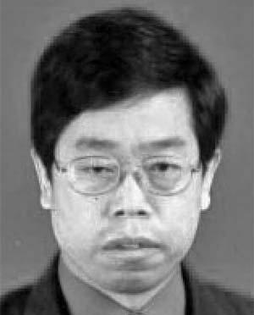

Qinbao Song received the PhD degree in computer science from Xi’an Jiaotong Univer-sity, China, in 2001. Currently, he is working as a professor of software technology in the Depart-ment of Computer Science and Technology, Xi’an Jiaotong University, where he is also the deputy director of the Department of Computer Science and Technology. He is also with the State Key Laboratory of Software Engineering, Wuhan University, China. He has authored or

coauthored more than 80 referred papers in the areas of machine learning and software engineering. He is a board member of the Open Software Engineering Journal. His current research interests include data mining/machine learning, empirical software engineering, and trustworthy software.


Jingjie Ni received the BS degree in computer science from Xi’an Jiaotong University, China, in 2009. Currently, she is working toward the master degree in the Department of Computer Science and Technology, Xi’an Jiaotong Uni-versity. Her research focuses on feature subset selection.
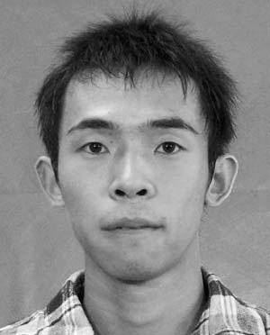

Guangtao Wang received the BS degree in computer science from Xi’an Jiaotong Univer-sity, China, in 2007. Currently, he is working toward the PhD degree in the Department of Computer Science and Technology, Xi’an Jiao-tong University. His research focuses on feature subset selection and feature subset selection algorithm automatic recommendation.

- For more information on this or any other computing topic, please visit our Digital Library at www.computer.org/publications/dlib.

